H.T No
Regulations:
A20

Sreenidhi Institute of Science and Technology
(An Autonomous Institution)
Code No: 8B308 Date: 09-Sept-2024(FN)

B.Tech II-Year I- Semester External Examination, Sept - 2024 (Supplementary)
MACHINE DRAWING AND COMPUTER AIDED DRAWING PRACTICE (ME)

Time: 3 Hours Max.Marks:70

Note: a) No additional answer sheets will be provided.
b) All sub-parts of a question must be answered at one place only, otherwise it will not be valued.
c) Missing data can be assumed suitably.

Bloom's Cognitive Levels of Learning (BCLL)

Remember | L1 | Apply | L3 | Evaluate | L5
Understand | L2 | Analyze | L4 | Create | L6

Part - A Max.Marks:30

ANSWER ANY TWO QUESTIONS. EACH QUESTION CARRIES 15 MARKS.

1. | Sketch the conventional representation of at least four different thread forms. | L1 | [15M]
2. | Draw the sectional view from the front and view from the side of a cotter joint with sleeve used to connect two rods of 30 mm diameter each. | L3 | [15M]
3. | Draw the three views of a hexagonal headed bolt, hexagonal nut and a washer assembly. The nominal diameter of the bolt is 24 mm. Take the length of the bolt as 75 mm and thread length is 50 mm. | L3 | [15M]

Part – B Max.Marks:40
Part-B (is Compulsory 40 Marks)

4. |  | Assemble all the parts of the screw jack, shown in Figure and draw the sectional front view and top view.  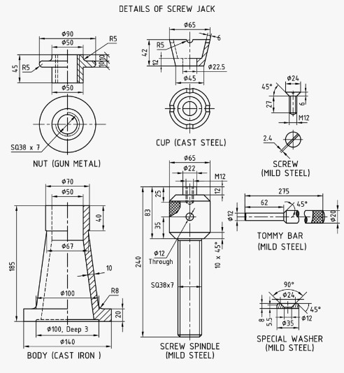 | L4 | 40M

-- 00 -- 00 –

